Important Dates for 2020-2021
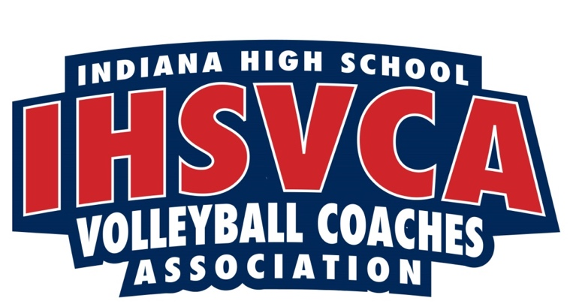
Below is the list of important dates for the Indiana High School Volleyball Coaches Association and the IHSAA. Please note the deadlines for each award. You can nominate at any time up to the deadline date listed. You MUST be a member of the IHSVCA to nominate players and no late nominations will be accepted.
- IHSVCA State Coaches Clinic- Sunday, August 2 Registration begins at 8:30 am
- IHSAA official start of fall practices- Monday, August 3
- First official IHSAA contest- Saturday, August 15
- IHSAA Tournament entry deadline- Monday, September 28.
- IHSAA Sectional Tournament Pairings Show- Sunday, October 4 7 pm ET/6pm CT, streamed on IHSAAtv.org hosted by Greg Rakestraw. Please share images of your team gathering with us @IHSVCA.
- IHSAA Sectional dates- October 13, 15, 17
- IHSAA Regional date- Saturday, October 24
- IHSAA Semi-State date- Saturday, October 31
- IHSVCA State Banquet- Friday, November 6
- IHSAA State Finals- Saturday, November 7
- IHSVCA All Star Tryouts- Sunday, November 15
- IHSVCA All-Star Matches- Sunday, November 22

AWARD DEADLINES:
October 5 Deadline
- IHSVCA Academic All-State Nominations due http://ihsvca.com/awards/student-athlete/academic-all-state/
October 12 Deadline
- All-District/All-State/All-Star Nomination form link: http://ihsvca.com/register/all-districtall-stateall-star/
October 19 Deadline
- District Coach of the Year nomination form link: http://ihsvca.com/register/district-coach-of-the-year
- State Coach of the Year nomination form link: http://ihsvca.com/register/state-coach-of-the-year/
- Assistant Coach of the Year nomination link: http://ihsvca.com/register/assistant-coach-of-the-year/
- Hall of Fame nomination form link: http://ihsvca.com/register/hall-of-fame/

October 26 Deadline– Victory Club/Program Milestone/Coaches Under 30
- http://ihsvca.com/awards/coaches/victory-club/
- http://ihsvca.com/register/program-milestones/
- Coaches Under 30 Award: http://ihsvca.com/awards/coaches/coaches-under-30
Directions for All-State Nomination.
This is a 2-step process:
- Log into your MaxPreps account and click on IN Award Nomination under Nominations heading, follow the prompts to select the players you wish to nominate
- Once you have finished the MaxPreps portion, go here to nominate for All-District/All-State/All-Star

